Week 5 Rankings: Is your school one of the top teams in Illinois?
AddThis Sharing Buttons
Share to Facebook
Share to Twitter
Share to Print
Share to More
1
ILLINOIS XC 2013: REGULAR SEASON RANKINGS
Tony Jones
Oct 2, 2013

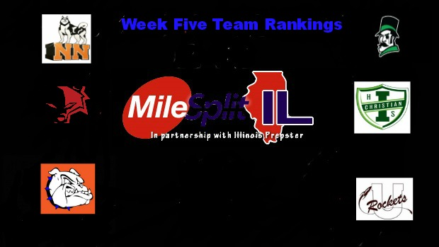

Tony Jones takes a look at the top teams across the state of Illinois for week five.

Boys 3A-
1. Elmhurst (York)
2. Hinsdale Central
3. O’Fallon
4. Arlington Heights (Hersey)
5. Downers Grove North
6. Buffalo Grove
7. New Lenox (Lincoln-Way Central)
8. Chicago Lane Tech
9. Naperville (Neuqua Valley)
10. Orland Park (Sandburg)
11. Winnetka (New Trier)
12. Chicago (St. Ignatius)
13. Wheaton-Warrenville South
14. LaGrange (Lyons Twp.)
15. Naperville North
16. Palatine
17. Roselle (Lake Park)
18. Plainfield South
19. Highland Park
20. Park Ridge (Maine South)
21. Barrington
22. Wilmette (Loyola Academy)
23. Batavia
24. Algonquin (Jacobs)
25. Mt. Prospect (Prospect)

Girls 3A-
1. Naperville North
2. Palatine
3. Winnetka (New Trier)
4. Glen Ellyn (Glenbard West)
5. Hinsdale Central
6. O’Fallon
7. Wheaton-Warrenville South
8. Oak Park-River Forest
9. Hoffman Estates
10. Lockport
11. LaGrange (Lyons Twp.)
12. Schaumburg
13. Naperville Central
14. Barrington
15. Downers Grove North
16. St. Charles North
17. Naperville (Neuqua Valley)
18. Geneva
19. Orland Park (Sandburg)
20. Downers Grove South
21. Lake Zurich
22. Algonquin (Jacobs)
23. St. Charles East
24. Elmhurst (York)
25. Cary-Grove

2A Boys-
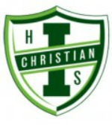
1. Lansing (Illiana Christian)
2. Mahomet-Seymour
3. Chicago Jones Prep
4. Yorkville
5. Normal (University)
6. Vernon Hills
7. Crystal Lake Central
8. Dixon
9. Metamora
10. Glen Ellyn (Glenbard South)
11. Rock Island Alleman)
12. Lisle (Benet Academy)
13. Springfield
14. Chatham-Glenwood
15. West Chicago (Wheaton Academy)
16. Champaign Central
17. Sterling
18. Taylorville
19. Belvidere North
20. Sycamore

2A Girls-
1. Yorkville
2. Glen Ellyn (Glenbard South)
3. Normal (University)
4. Crystal Lake Central
5. Woodstock
6. Lombard (Montini)
7. Mattoon
8. Peoria (Notre Dame)
9. Highland
10. Lake Forest
11. Springfield
12. Belvidere North
13. Lemont
14. Lake Villa (Lakes)
15. Vernon Hills
16. Maple Park (Kaneland)
17. Dunlap
18. Marengo
19. Metamora
20. Geneseo

1A Boys (Alex G’s rankings)-
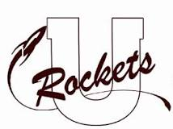
1. Tolono (Unity)
2. Winnebago
3. Rockford (Christian)
4. Monticello
5. Shelbyville
6. St. Joseph (Ogden)
7. Rochester
8. Tremont
9. Urbana (University)
10. Champaign (St. Thomas More)
11. Sterling (Newman Catholic)
12. Mt. Zion
13. Elmwood-Brimfield
14. Freeburg
15. Stanford (Olympia)
16. Pleasant Plains
17. Paxton-Buckley-Loda
18. El Paso-Gridley
19. Liberty
20. Sparta

1A Girls (Alex G’s rankings)- 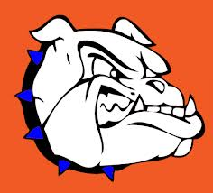
1. Decatur (St. Teresa)
2. Monticello
3. Rochester
4. St. Joseph-Ogden
5. Eureka
6. Chicago (Latin)
7. Tolono (Unity)
8. Liberty
9. Monmouth-Roseville
10. Litchfield
11. Freeburg
12. Byron
13. Carlinville
14. Mt. Zion
15. Petersburg (Porta)
16. Winnebago
17. Urbana (University)
18. Effingham (St. Anthony)
19. Downs (Tri-Valley)
20. Kankakee (McNamara)

