Week 2 Team Rankings
AddThis Sharing Buttons
Share to Facebook
Share to Twitter
Share to Print
Share to More
ILLINOIS XC 2013: REGULAR SEASON RANKINGS
Tony Jones
Sep 11, 2013

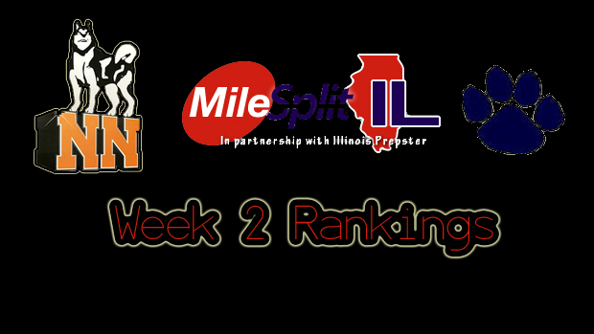
Week 2 Rankings
(Week of 9/11-17, 2013)

Class 3A Boys-

1. O’Fallon
2. Elmhurst (York)
3. Hinsdale Central
4. Downers Grove North
5. Arlington Heights (Hersey)
6. Winnetka (New Trier)
7. Wheaton-Warrenville South
8. Naperville (Neuqua Valley)
9. Naperville North
10. Palatine
11. New Lenox (Lincoln-Way Central)
12. Orland Park (Sandburg)
13. LaGrange (Lyons Twp.)
14. Chicago Lane Tech
15. Roselle (Lake Park)
16. Barrington
17. Chicago (St. Ignatius)
18. Edwardsville
19. Buffalo Grove
20. Plainfield South
21. Wilmette (Loyola Academy)
22. Naperville Central
23. Algonquin (Jacobs)
24. Palatine (Fremd)
25. Highland Park

Class 3A Girls-

1. Naperville North
2. Palatine
3. Glen Ellyn (Glenbard West)
4. O’Fallon
5. Naperville Central
6. Winnetka (New Trier)
7. Downers Grove South
8. Hoffman Estates
9. Hinsdale Central
10. LaGrange (Lyons Twp.)
11. Minooka
12. St. Charles North
13. Geneva
14. Park Ridge (Maine South)
15. Algonquin (Jacobs)
16. Orland Park (Sandburg)
17. Lockport
18. Schaumburg
19. St. Charles East
20. Oak Park-River Forest
21. Naperville (Neuqua Valley)
22. Downers Grove North
23. Barrington
24. Wheaton-Warrenville South
25. Elmhurst (York)

Class 2A Boys-

1. Lansing (Illini Christian)
2. Glen Ellen (Glenbard South)
3. Crystal Lake Central
4. Yorkville
5. Springfield
6. Normal (University)
7. Vernon Hills
8. Mahomet-Seymour
9. Chicago Jones
10. Dixon
11. Maple Park (Kaneland)
12. Pontiac
13. Metamora
14. Dunlap
15. Rock Island (Alleman)
16. Sycamore
17. Grayslake Central
18. Lisle (Benet Academy)
19. Chatham-Glenwood
20. Belvidere North

Class 2A Girls-

1. Yorkville
2. Normal (University)
3. Crystal Lake Central
4. Marengo
5. Glen Ellyn (Glenbard South)
6. Maple Park (Kaneland)
7. Lombard (Montini)
8. Peoria (Notre Dame)
9. Chatham-Glenwood
10. Vernon Hills
11. Lake Forest
12. Mattoon
13. Crystal Lake (Prairie Ridge)
14. Woodstock
15. Dunlap
16. Lemont
17. Highland
18. Belvidere North
19. DeKalb
20. Springfield

Class 1A Boys-

1. Elmwood-Brimfield
2. Champaign (St. Thomas More)
3. Winnebago
4. Shelbyville
5. Tolono (Unity)
6. Rochester
7. Tremont
8. Pleasant Plains
9. Mt. Zion
10. Monticello
11. St. Joseph-Ogden
12. Stanford (Olympia)
13. Freeburg
14. Sterling (Newman Central Catholic)
15. Chicago (Latin)
16. Rockford (Christian)
17. Paxton-Buckley-Loda
18. Monmouth (Monmouth-Roseville)
19. Sparta
20. Urbana (University)

Class 1A Girls-

1. Monticello
2. Decatur (St. Teresa)
3. Rochester
4. St. Joseph- Ogden
5. Petersburg (Porta)
6. Carlinville
7. Tolono (Unity)
8. Winnebago
9. Rock Falls
10. Downs (Tri -Valley)
11. Rockford (Lutheran)
12. Monmouth (Monmouth-Roseville)
13. Henry (H.-Senachwine)
14. Byron
15. Elmwood-Brimwood
16. Mt. Zion
17. Kankakee (Mcnamara)
18. Urbana (University)
19. Effingham (St. Anthony)
20. Champaign (St. Thomas Moore)

