REGIONAL CROSS COUNTRY

Franklin, Mahomet boys come out on top
- Randy Sharer rsharer@pantagraph.com Oct 22, 2016

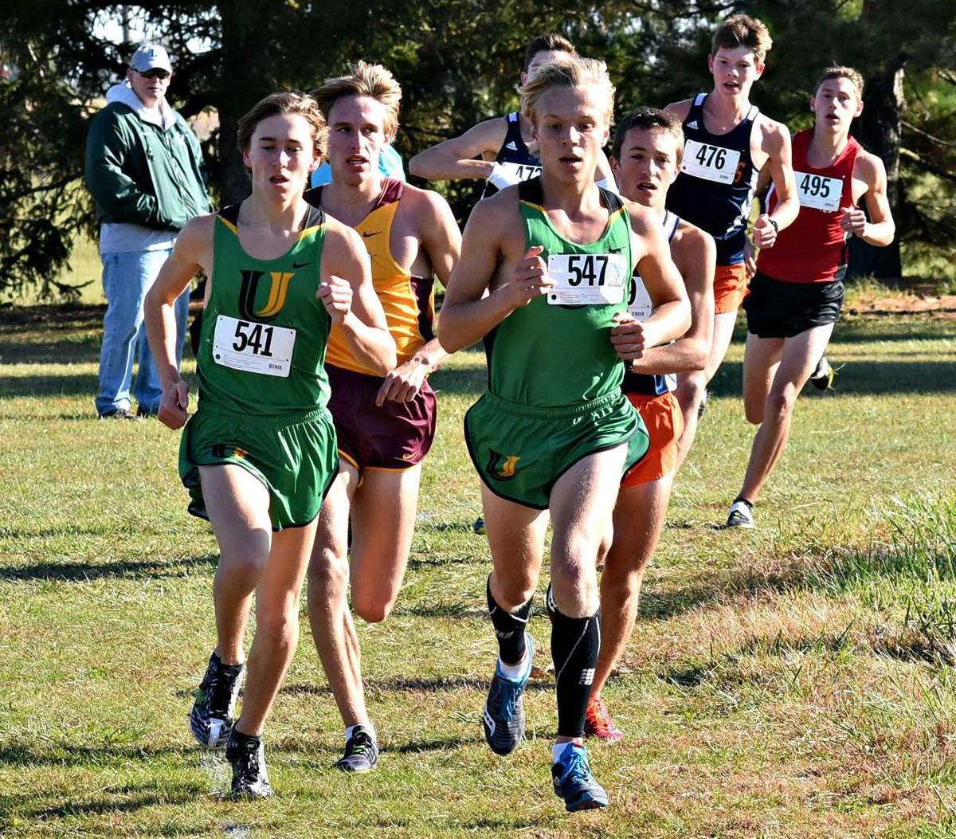

RANDY SHARER, THE PANTAGRAPH
University High School's Jack Franklin (541) and Jared Schuckman (547) shared the lead at the mile mark during Saturday's U High Class 2A Regional cross country meet at Normal's Maxwell Park. Franklin went on to win the 3-mile race in 14 minutes, 46 seconds.

NORMAL — After taking a race off to rest a tight hip and then suffering through an off day during the Corn Belt Conference Meet, Jack Franklin had his fans concerned.
The University High School senior allayed their worries during Saturday's U High Class 2A Cross Country Regional by winning on Maxwell Park's 3-mile layout in 14 minutes, 46 seconds.
"I still knew I had it," said Franklin after posting a 13-second margin of victory over Metamora runner-up Jake Gillum. "I never felt like I was dying."
No. 2-state ranked U High advanced second to next Saturday's Metamora Sectional despite resting No. 3 man Zach Wolford.
No. 1-ranked Mahomet-Seymour, which rested four of its top seven, topped the Pioneers, 39-53. No. 5 Metamora took third with 76. Bloomington grabbed the sixth and final qualifying spot with 149 points, edging Washington by five.
"Next week I think we'll run everybody and try to make another run at Mahomet, which is obviously a really good team, probably the best I've ever raced against," Franklin said.
The Bulldogs packed five in the top 16 led by Brian Butcher in third (15:03) and Corn Belt champion Gabe Pommier in fourth (15:06).
"Brian Butcher really stepped it up and we needed him to," said Mahomet-Seymour coach Neal Garrison, whose team is ranked 15th nationally. "It's probably the first time he's placed first for his team."
U High's Jared Schuckman rounded out the top five in 15:08. Schuckman was by Franklin's side through opening miles of 4:55 and 5:06.
"I think the two of them being able to run together as far as they did gave (Jack) the confidence to finally say 'hey, now I can go,'" said U High coach Lester Hampton.
Coach John Szabo said BHS turned in a team effort that was aided by No. 3 man Jack Doud's season best of 16:32 in 29th. It was only his third race of the year due to injury. The Purple Raiders were led by Nick Doud (17th, 15:59). The team's five-man finishing split was a season-best 74 seconds.
Eighth-place Lincoln (213) saw junior Blake Jones qualify individually in 18th (16:00).

