STATE CROSS COUNTRY

Mahomet boys run to team title; Franklin, U High grab third

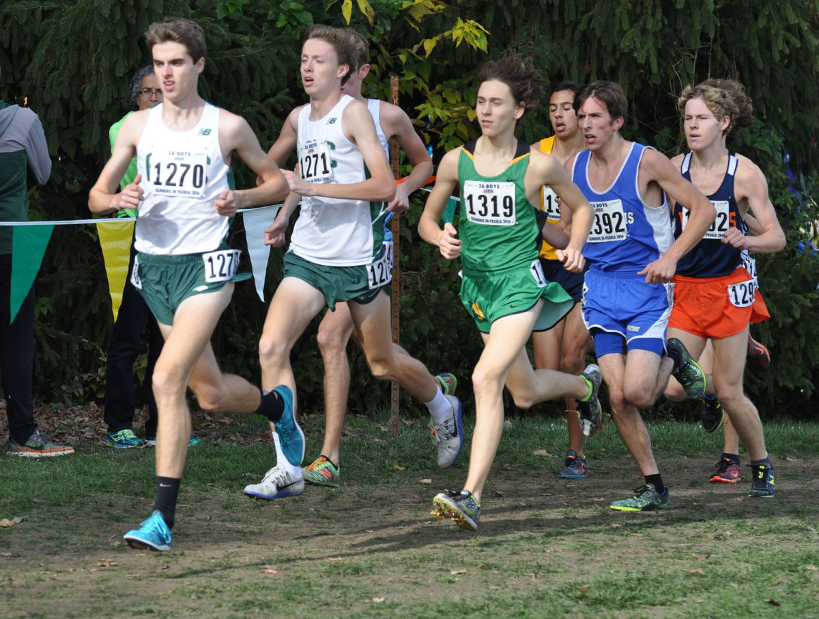

- PHOTO COURTESY DOUG GILLAM
University High's Jack Franklin (1319) runs with the lead pack in Saturday's Class 2A boys state cross country meet at Detweiller Park in Peoria. Franklin finished third in 14 minutes, 30 seconds while helping the Pioneers to a third-place team finish as well.

PEORIA — On a lightning fast day at Detweiller Park, no one who wasn't named Aho was faster than University High School's Jack Franklin at the Class 2A boys state cross country meet on Saturday.
Team wise, no one was faster than Mahomet-Seymour, period. After finishing second the past two years, the Bulldogs placed six runners in the top 25 to finally get over the hump and claim the 2A title.
The crown culminates a season in which the Bulldogs enjoyed a No. 1 statewide ranking from start to finish.
The victory came as somewhat of a relief for Mahomet coach Neil Garrison.
"Last year we were ranked No. 1 and learned that the teams that are ranked No. 2 and 3 are really hungry to win it," Garrison said. "It was definitely something to watch out for, not to be arrogant and not to take anything for granted."
Meanwhile, Franklin and U High finished third with Grayslake Central, led by brothers Jack and Matt Aho, sandwiched between the Bulldogs and Pioneers in the runner-up spot.
After running a 14:31 on the Detweiller Park course earlier this season, Franklin set a school record by knocking a second off his time to improve on his sixth-place state finish a year ago.
"I thought I ran well," Franklin said. "I was hoping to get first or second, but I ran for the win and it cost me a bit in the end. But I'm really excited and really happy about what I did."
Runner-up Matt Aho got past Franklin in the final leg to claim second spot with a 14:27.
"I got out-kicked," Franklin said. "I just didn't have as much as Matt did at the end, but I got third and I'm happy. The course conditions were really good and I had great competition to push me. Everything just kind of worked out well."
U High's Jared Schuckman closed strong to finish just outside the top-10 to help the Pioneers to their third-place finish.
"The last 100 yards I just took off," Schuckman said. "I told myself it was now or never. I pumped my arms as fast as I could and passed a pack of five or six people right at the end."
Schuckman's 14:53 was a second off his personal best with his 11th-place finish the best of his career at state.
"I was just trying to run my best, go out slow, keep it conservative and finish hard," Schuckman said.
U High coach Lester Hampton was pleased with the podium finish after the Pioneers finished 10th each of the past two years.
"Coming in, a lot of times you hope for a little bit more, but anytime at this meet with only three trophies, if you can walk away with one of those trophies, you better be very happy about that," he said. "Right now nothing else matters except for these boys to get the opportunity to walk up on that podium. I'm ecstatic."
Mahomet-Seymour's victory is the third state championship for the Corn Belt Conference in the fall season, joining U High's boys golf and soccer teams.
"We had a good, solid year," Garrison said. "There wasn't a lot of down sides. We've been pretty healthy, both sickness-wise and injury-wise. The team morale has been good. We've got a small group and they take good care of each other."
The Bulldogs have only 18 runners in the program. Nearly all seven of the team's representatives on Saturday earned a medal.
"Our seventh was 27th, so he was close," Garrison said. "It was a group effort."
Class 1A: El Paso-Gridley and Deer Creek-Mackinaw scored top-10 finishes with EPG finishing ninth and Dee-Mack 10th. Elgin Harvest Christian claimed the Class 1A title.
EPG was paced by Adam Ludy, who finished 35th overall at 15:41, while Layden was 44th at 15:49.
Dee-Mack's Gary Cates posted a 15:45 for a 37th-place finish, tops among the Chiefs.
Class 3A: Normal West junior Tyler Dunn was the lone area competitor in Class 3A, placing 210th in 17:28.

