Cross Country 2017 Is On The Horizon; Catch It If You Can
Tony Jones
Jul 20, 2017

2A Boys-
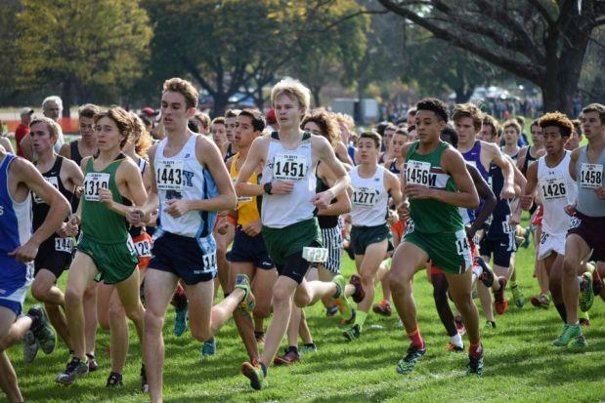
It should be another great season for the middle classification (Matt Jortberg photo)
Mahomet-Seymour was one of the best teams in Illinois last season across all classifications when they averaged 14:54 per man and produced a 23-second scoring split. The verdict of the analysis was a 58-134 destruction of previous state champion Grayslake Central who went 1-2 and had three runners in the scoring top ten. The Bulldogs later proved to be one of the nation's teams and earned an at-large bid to NXN. That wonderful experience should make this team a bullseye candidate this fall. Three of the top four scorers return plus some solid reserves who are ready to step in and fill any voids. Grayslake Central lose the Aho boys to graduation along with two more state meet participants. It will be tough on the Rams when last year's third placer Normal University. Metamora and Marion look to move into the top 5 state championship standings, both schools return 6 of 7 returners. How will former 3A mainstay Crystal Lake South fit into the picture here? You will have to read the full preview in mid-August to find out.
The race for individual supremacy will be up for grabs after the top three runners graduated. Two-time champion Jack Aho has moved on the University of Michigan. The next top returner is Matt Richtman of Kaneland and he continues to rise entering his senior year. Richtman ran 14:36 to take 4th and then proceeded to place 2nd on the track in the 3200m. It should be a piece of cake for the lad correct? Not so fast! Fellow senior to be Jack Becker of Crystal Lake South drops into the party. Becker placed 20th in 3A last year and he as well had a solid season on the track. His 9:24.51 3200m may have put him right on Richtman's tail had he competed on the same track in Charleston last spring. Well, hopefully if all goes well it should fast one but a fun one. Oh yeah, we did not forget Jacob Gebhardt. The rising kid from Sterling will now translate his newfound track prowess to the grass.

