The Best Of The Rest All Star Collage: 2A Gem Stars
AddThis Sharing Buttons
Share to FacebookMore
IHSA STATE CHAMPIONSHIP
Tony Jones
Nov 21, 2017
Prev
Page 3 of 3
2A Boys-
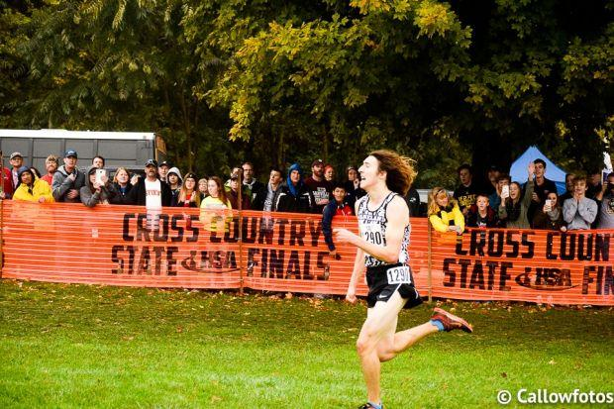
Matt Richtman (Sr., Maple Park Kaneland) STATE CHAMPION- 14:23
Major wins: Sycamore Invite, FTTF Invite, Kaneland Invite, Burlington Central Regional, State Championship
Richtman avenged his three losses to Jacob Gebhardt with the big close victory in Peoria
Richtman improved from 4th place to champion
Personal Records
- 1600m (in) - 4:37.07
- 1600m - 4:17.92
- 2K Steeple - 6:47.01
- 3200m (in) - 9:34.70
- 3200m - 9:22.98
- 2 Mile (xc) - 11:39.50
- 3 Mile (xc) - 14:23.00
- 5K (xc) - 15:34.40
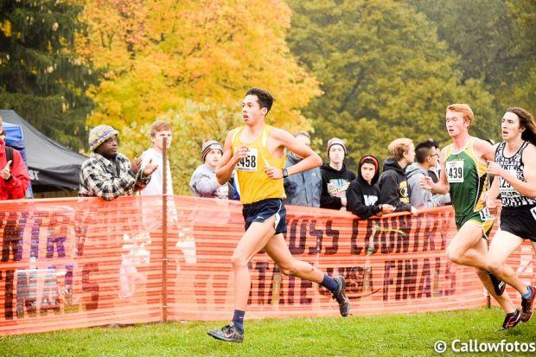
Jake Gebhardt (Sr., Sterling) STATE RUNNER UP- 14:23
Major wins: Rock River Run, Peoria Invitational, Sterling Invite, NIB-12 Conference Championship, Belvidere Regional, Kaneland Sectional
Only two losses were to state champion Matt Richtman
Personal Records
- 800m (in) - 2:06.63
- 800m - 1:58.46
- 1600m (in) - 4:32.07
- 1600m - 4:14.51
- 3200m (in) - 9:42.89
- 3200m - 9:18.11
- 3 Mile (xc) - 14:23.00
- 5K (xc) - 15:39.20

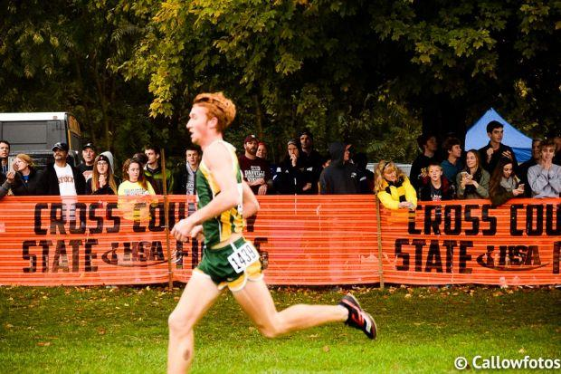
Jack Becker (Sr., Crystal Lake South) 3rd place- 14:31

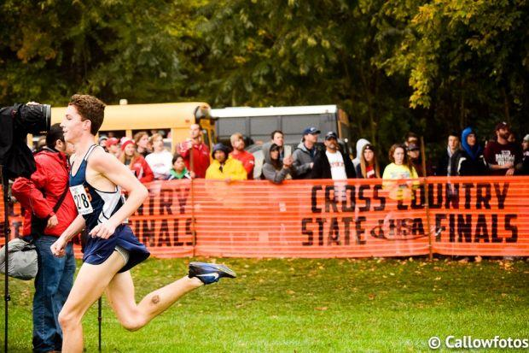
Mathias Powell (Jr., Mahomet-Seymour) 4th place- 14:45
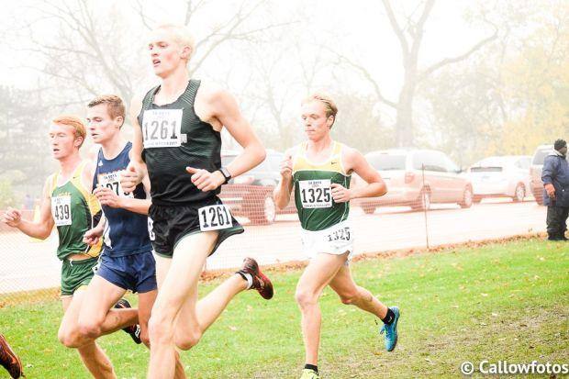
Austin Ohm (Sr., Lansing Illiana Christian) 5th place- 14:47
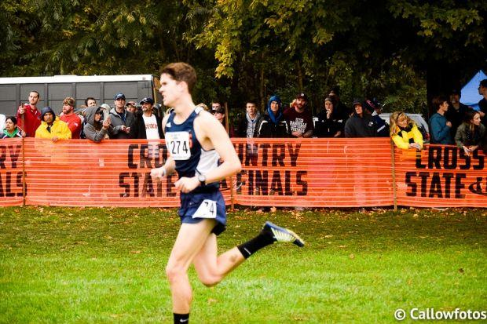
Riley Fortune (Sr., Mahomet-Seymour) 6th place- 14:48
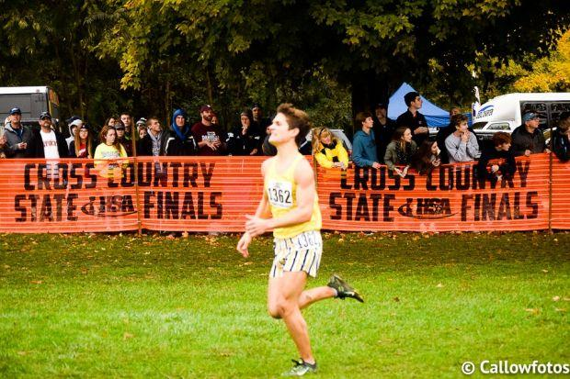
Stephen Poorten (Sr., Sycamore) 7th place- 14:56
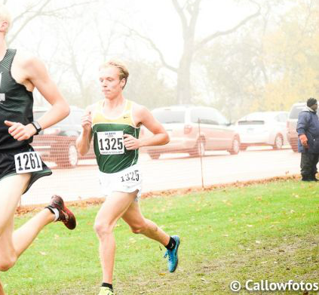
Jared Schuckman (Sr., Normal University) 8th place- 15:00
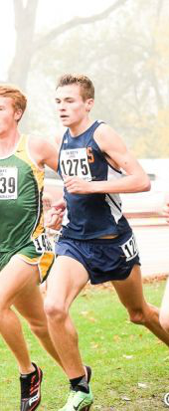
Ryan Hodge (Sr., Mahomet-Seymour) 9th place- 15:02

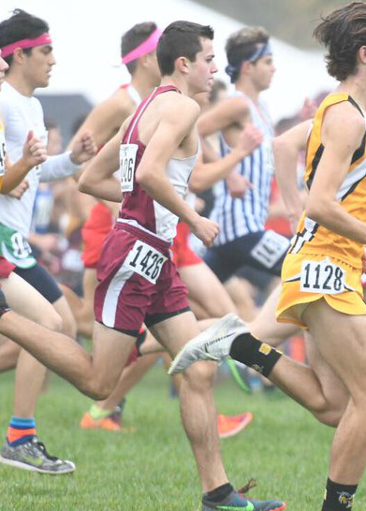
Charlie Smith (So., Antioch) 10th place- 15:02

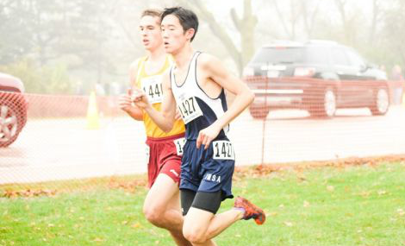
Daniel Chen (Jr., Aurora Illinois Math and Science Academy) 11th place- 15:03

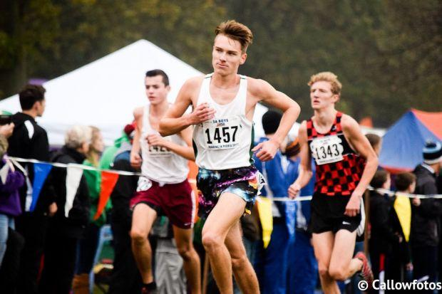
Spencer Smith (Sr., Rock Island Alleman) 12th place- 15:05

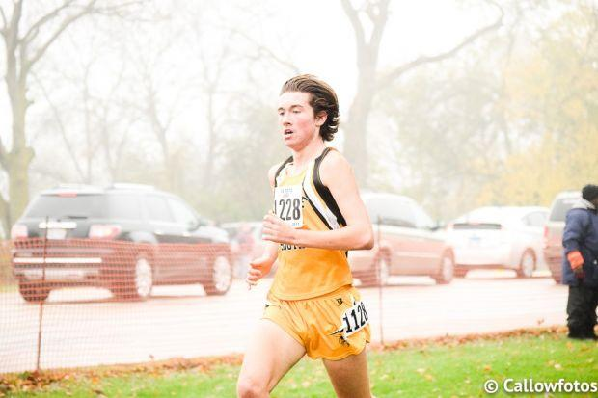
Brett Haffner (Sr., Darien Hinsdale South) 13th place- 15:06
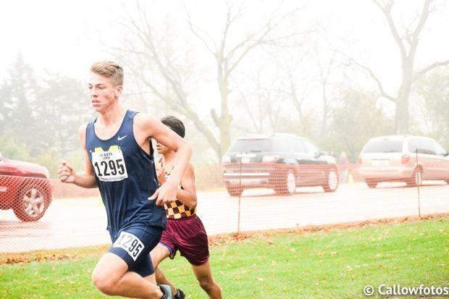
John Bruce (So., Marion) 14th place- 15:08
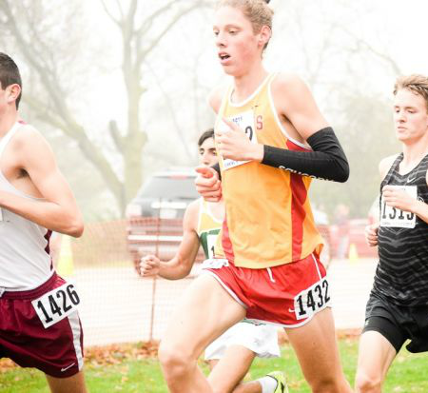
Nick Oakley (Sr., Charleston) 15th place- 15:10
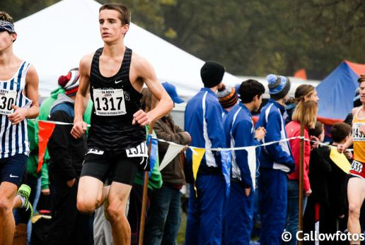
Charlie Wetzel (Sr., Normal West) 16th place- 15:10
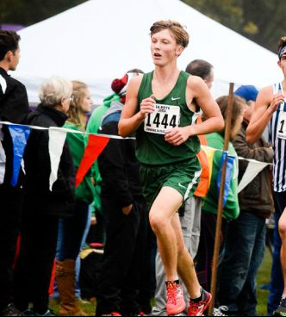
Blake Jones (Sr., Lincoln) 17th place- 15:13

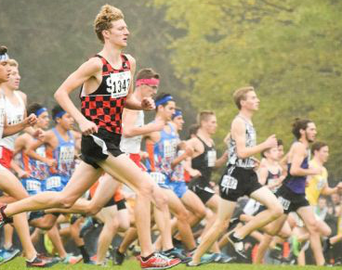
Kyle Boughter (So., Springfield) 18th place- 15:13

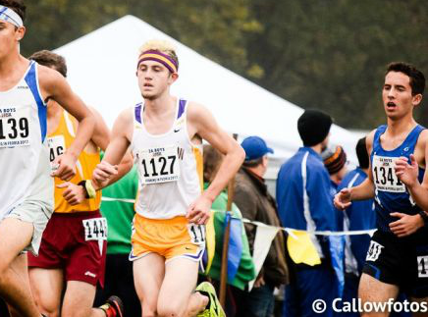
Austin Bicknell (Sr., Bloomington) 19th place- 15:14

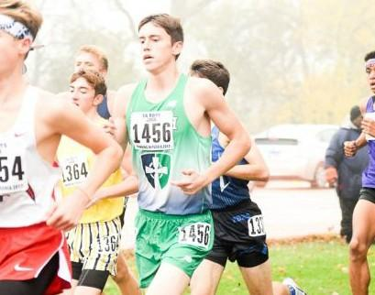
Chris Gilbert (Jr., Peoria Notre Dame) 20th place- 15:15
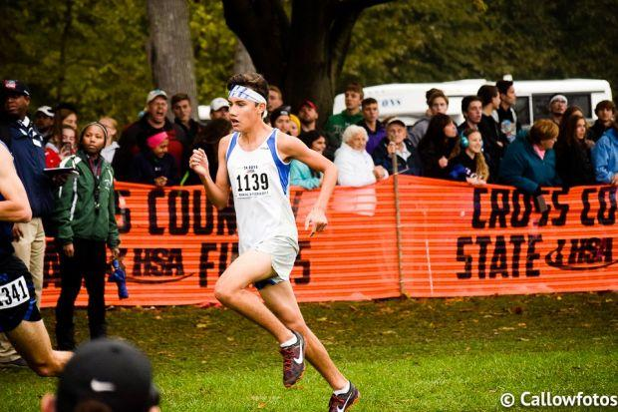
Anthony Farmer (So., Burlington Central) 21st place- 15:16
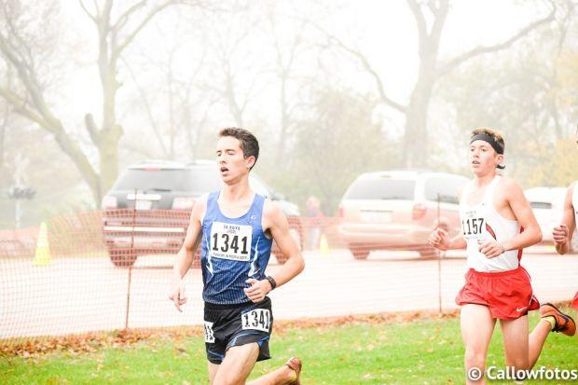
Jacob Wardzala (Sr., Riverside-Brookfield) 22nd place- 15:16

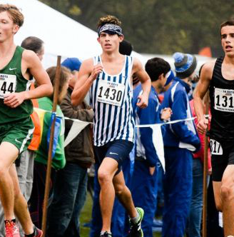
Luke Manolakes (So., Champaign Centennial) 23rd place- 15:16

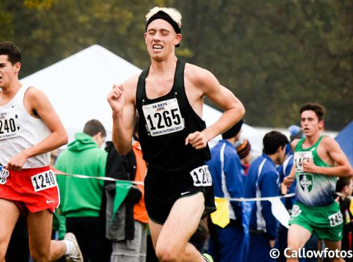
Derek Van Prooyen (Sr., Lansing Illiana Christian) 24th place- 15:16
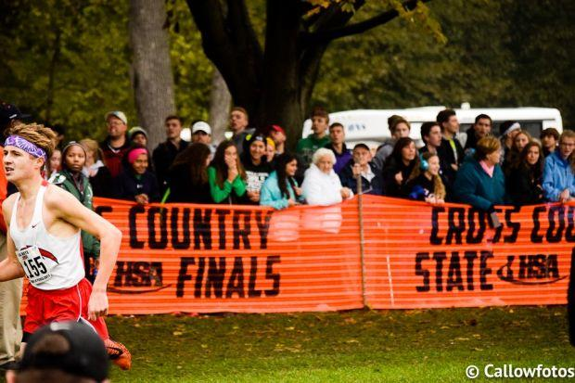
Drey Maton (Jr., Chatham-Glenwood) 25th place- 15:17

