Richard Spring Invite Preview Presented by Peoria Notre Dame
Tony Jones
Sep 15, 2017
Boys-
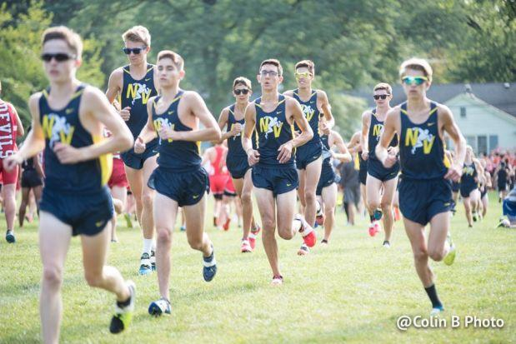
The Neuqua Valley Wildcats will be on the prowl this Saturday at Detweiller
Race times:
Boys- Varsity 11a, Frosh-Soph 11:40a, Open 12:20p
Ranked Teams:
3A- #2 Naperville (Neuqua Valley), #3 Elmhurst (York), #4 Wheaton-Warrenville South, #9 Orland Park (Sandburg), #12 Plainfield South, #15 Arlington Heights (Hersey), #16 Barrington, #19 O'Fallon, #25 St. Charles East
2A- #1 Mahomet-Seymour, #2 Normal (University), #3 Chatham-Glenwood, #10 Deerfield
1A- #2 St. Joseph-Ogden, #5 Freeburg, #16 Monticello, #24 Champaign (St. Thomas More)
This will be a meeting of the best of the rest if you will. There are not as many featured teams as the First To The Finish Invitational, but arguably the Neuqua Valley could be the best team in Illinois after this weekend depending on who you follow. Coach Paul Vandersteen commands the defending meet champion Wildcats. His charges are expected to be at their best with junior Zach Kinne leading the way. At the Hinsdale Invitational, the team was held back somewhat because of intense training. They should be tempered a bit now having to face some great teams.
This was supposed to be York's first full cast meet of the season. But some untimely illnesses and injuries may keep the Dukes grounded this weekend. Senior Charlie Kern was expected to make his official season debut in an invitational, but he is not feeling well. Though he ran a splendid 14:31 at the Detweiller at Dark meet, he has yet to race IHSA style. The pre-season numbers look good on paper. This early season test would have been a true indicator for him and hopefully the replacements can stand up strong on the finish llne.
Will this be the meet that Wheaton South load their "full" team? They have been incredibly strong through the first four starters and a big fall off at #5. If they move up sophomore David Zeller they could challenge for a top two spot.... mainstays like Sandburg, Barrington, and Hersey will look to prove they are ready to show how good their teams are. All of them have solid packs and this is an opportunity to tighten things up even more.
We will see where 2A power Mahomet-Seymour sits among the big school giants. The Titans were second last year. They have many good parts back for another state championship run. Within the battle of a battle, look for Normal U High and Chatham-Glenwood to disturb the pecking order.
The race for the finish line will be a tough one. Dylan Jacobs (Sr., Sandburg) will be on display and probably more focused than usual after losing handily to Danny Kilrea (Sr., Lyons Twp.) a few weeks ago. If Kern is not in the lead or running, then keep your eyes peeled for Logan Hall (Sr., Arthur). He is on his way to a record season on the Class A level at the very least. Following in the footsteps of his mentor Jon Davis, former of Oakwood and now U of lllinois.

