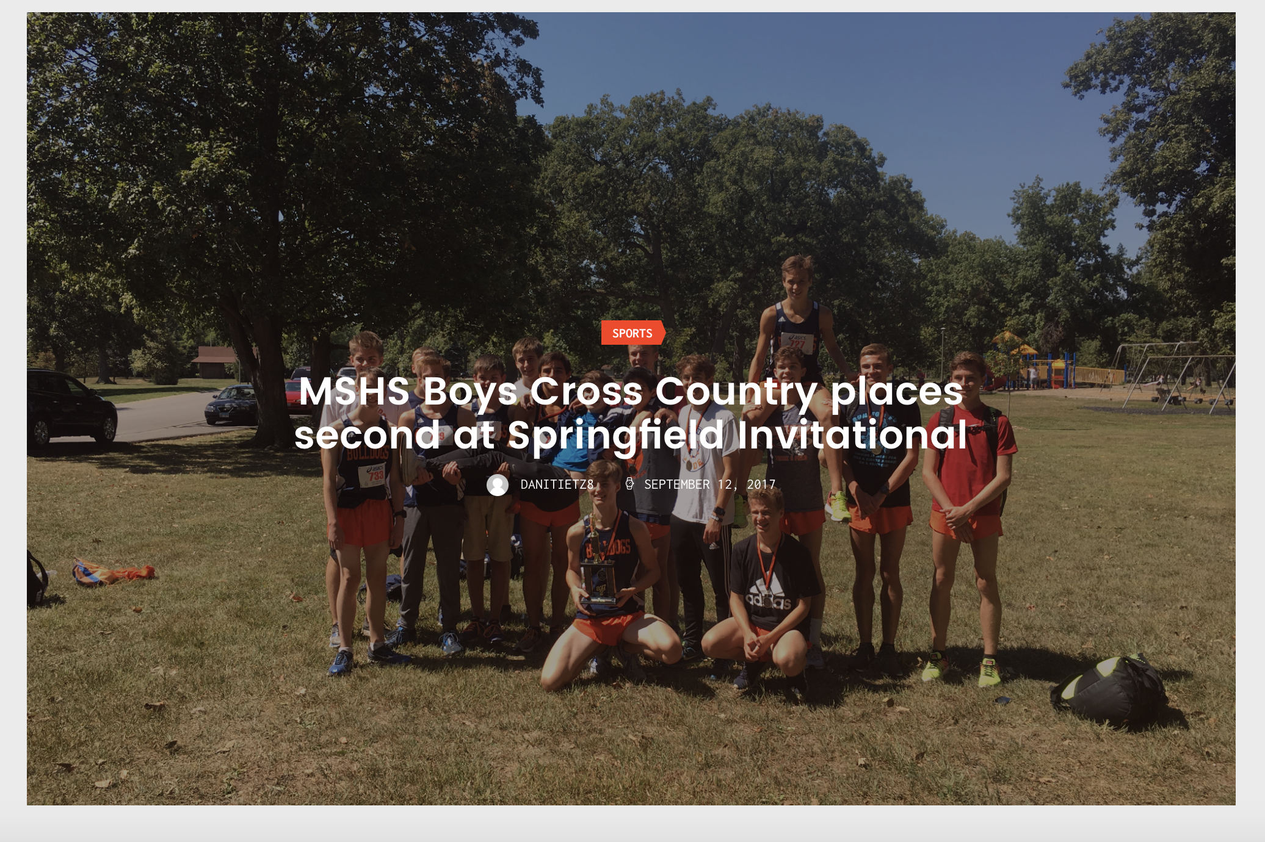

The first ranked AA Mahomet-Seymour Bulldogs finished second behind the seventh ranked AAA Mundelein at the Springfield Invitational Saturday.
Ryan Hodge finished second, followed by Mathias Powell in third, Riley Fortune in 7th, Bryson Keeble in 13th and Kaelen Davs in 24th place.
Joe Taylor and Calen Dowers earned 10th and 11th place in the freshmen race. And David Wilcoski finished sixth while Nate Douglas finished 15th in the open race.

